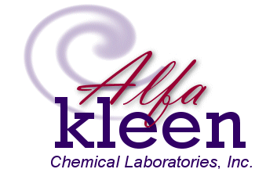
3681 Sacramento St., San Luis Obispo, CA 93401
800-676-0059, 805-541-3465, Fax: 805-541-3467
Email: John@alfakleen.com, www.alfakleen.com

“Friendlier Products for a Safer Planet”

John Calicchio, President

